Jillian Preece

Lab 6

Database Management

February 28, 2017

--Number 7

A left outer join takes each value from the LEFT table, and combines it with matching values from the RIGHT table, displaying ‘null’ where there is not a matching value. A right outer join takes each value from the RIGHT table and combines with matching values from the LEFT table, displaying ‘null’ where there is not a matching value.

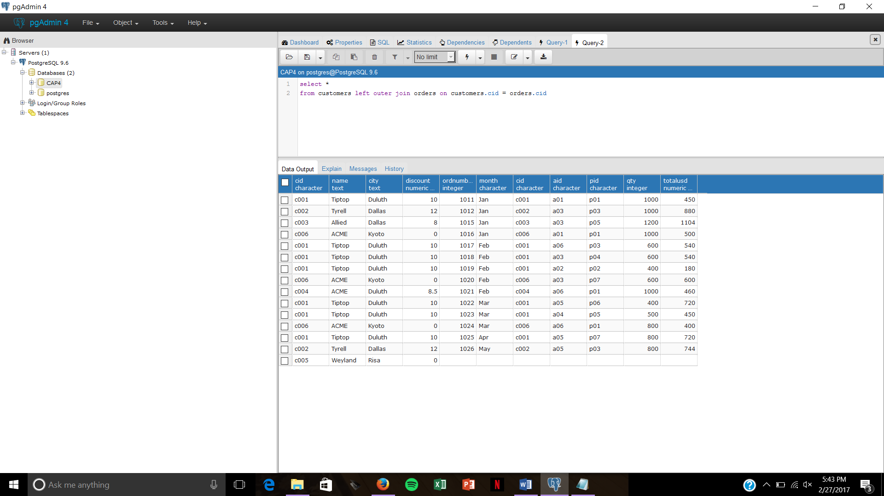

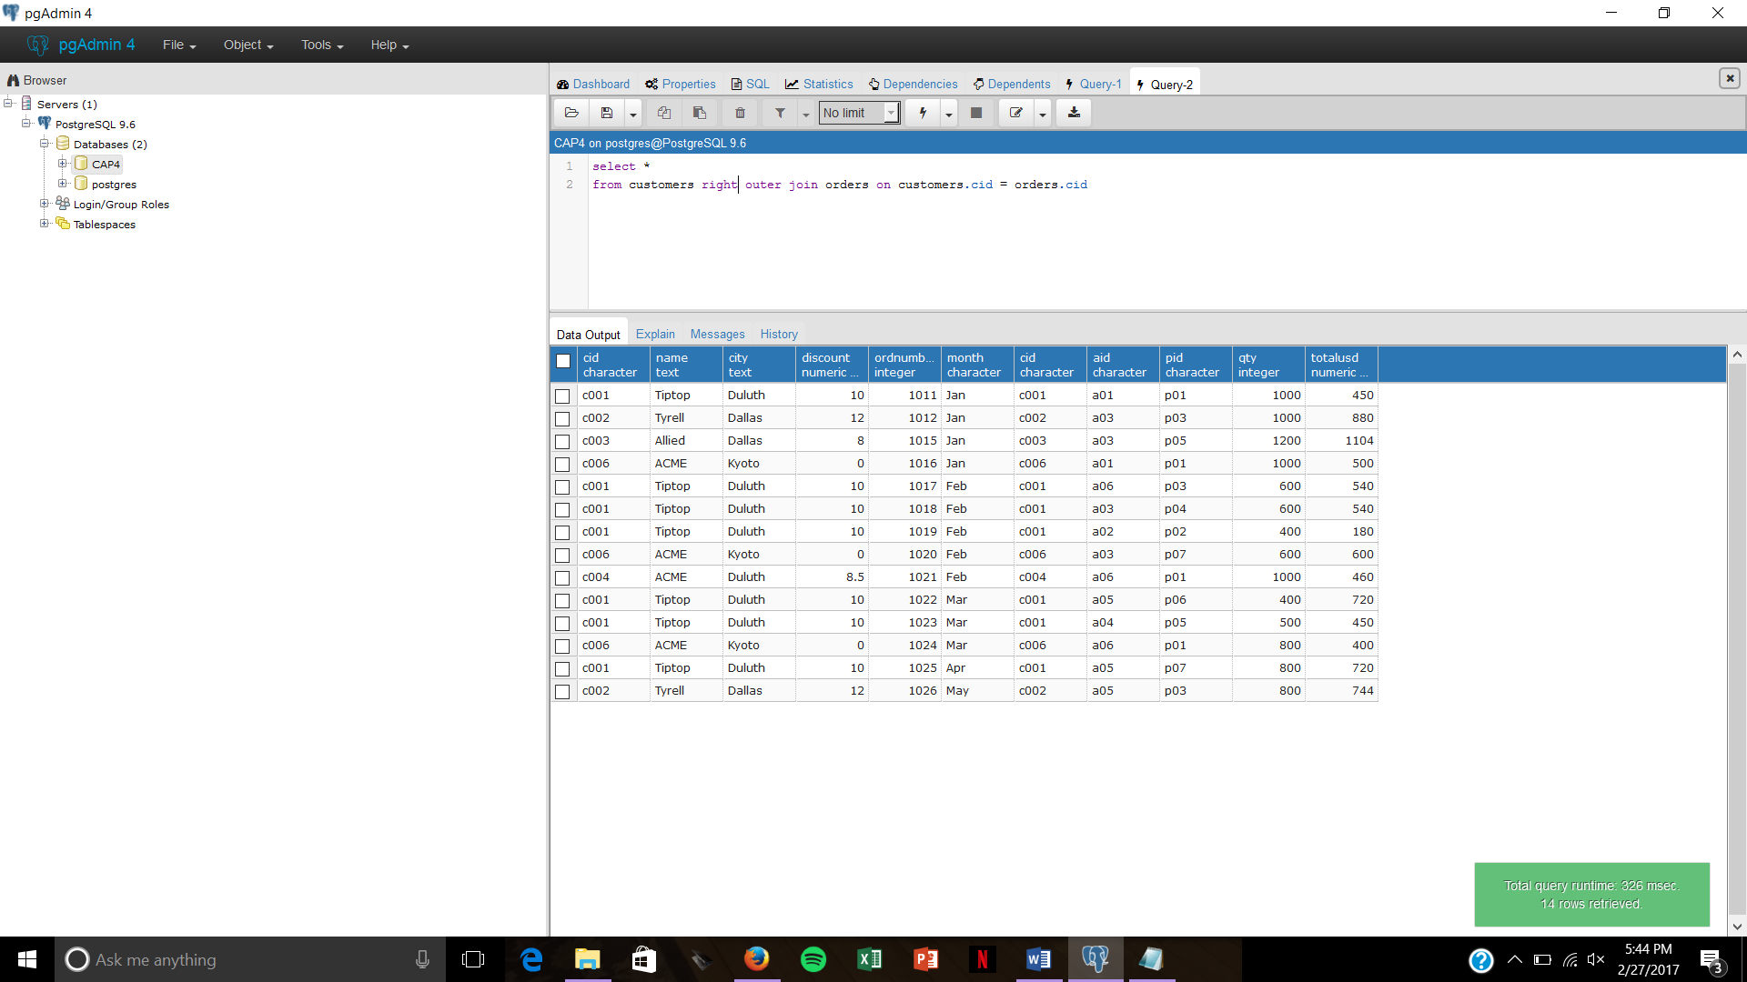

This shows the difference between left and right outer joins. The left outer join shows each customer, so c005 is included. However, the right outer join only displays each order, and since c005 didn’t place an order, that customer isn’t displayed at all in the table.